SPARKY FISHING OPENER
Brothers and sisters are invited to a fun-filled day of fishing on the Mississippi River!
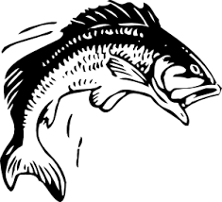
WHEN: June 10th, 2017
TIME: 8 am to 3 pm
WHERE: Meet 1-mile south of the West Newton landing. The beach is located on the MN side.
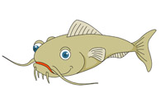
WHAT: Fishing for the Biggest: Walleye, Pan Fish, Bass, Northern, & Rough Fish

You must have one IBEW member in boat. We will weigh in at 3pm with food and prizes afterwards.
Questions, call Chris Hallett (251-3569) or John Powrie (259-5413).

